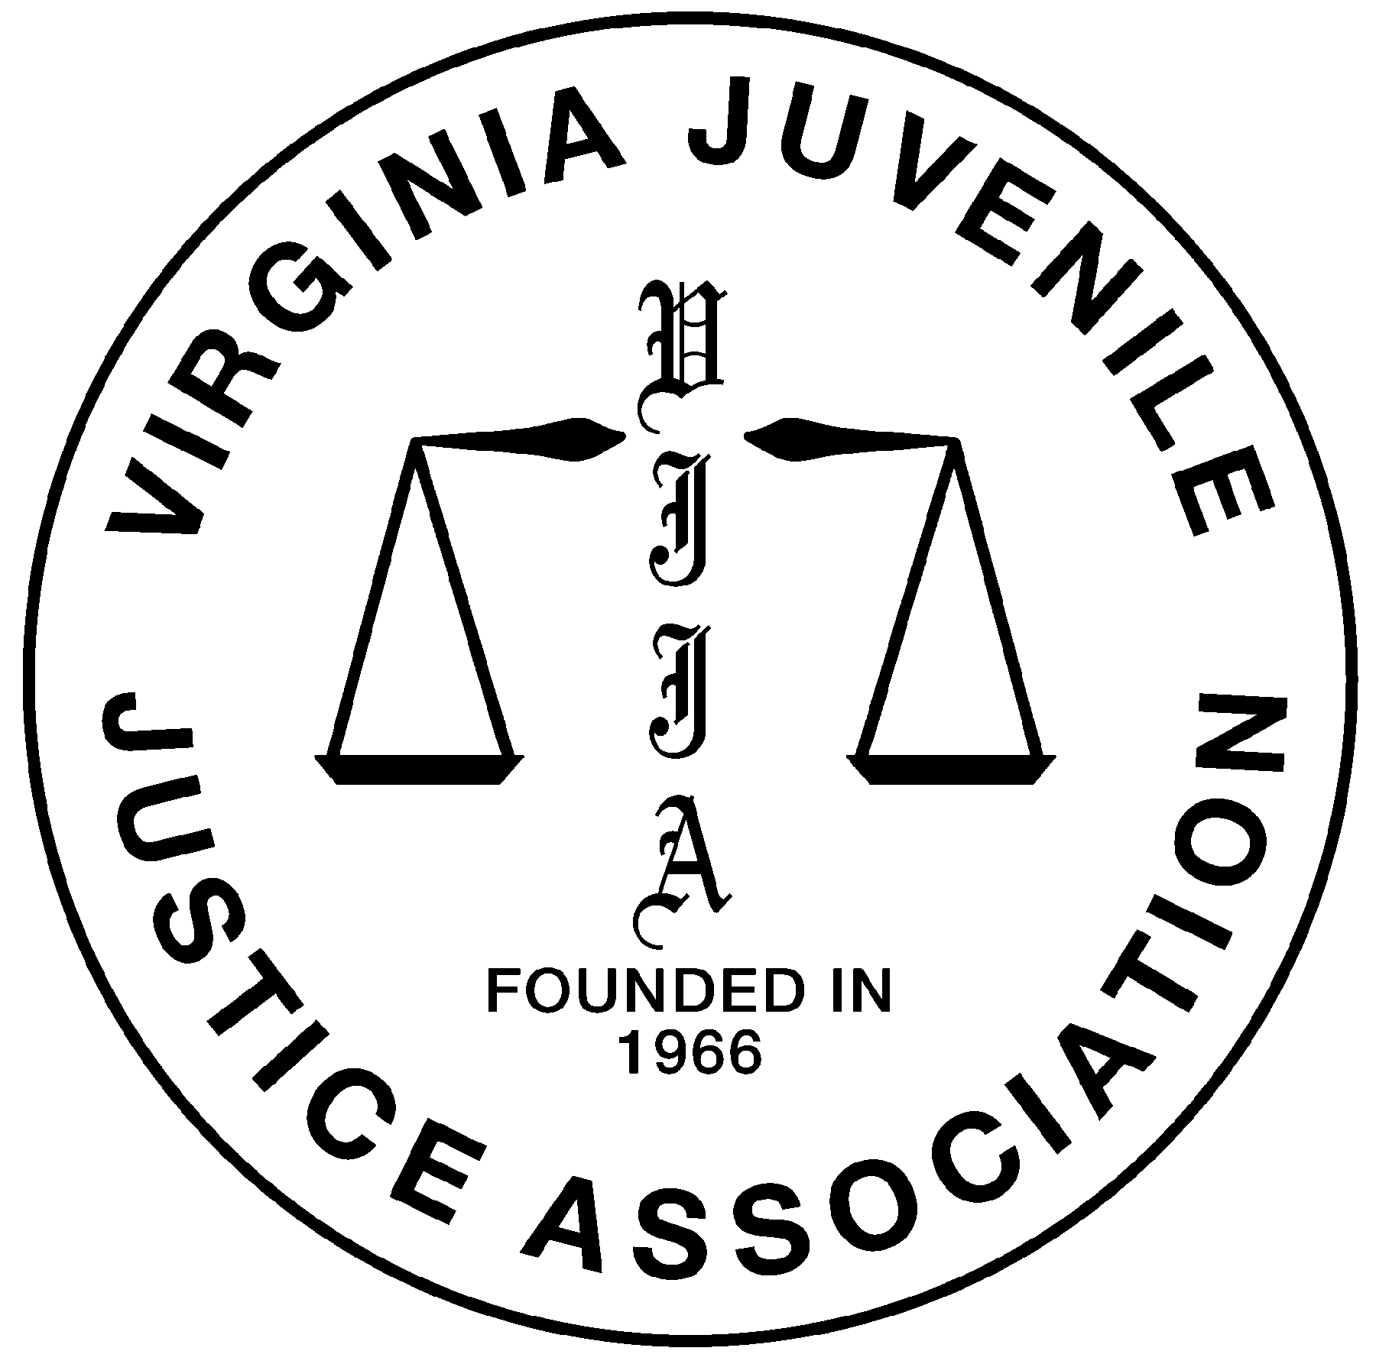 | Call for PresentERS  31st Fall Juvenile Justice Training Institute  November 7-9, 2007 • Roanoke (The Star City), Virginia  (and other ’07 venues)

The Virginia Juvenile Justice Association (VJJA) has issued a “Call for Presenters” for the 31st Fall Juvenile Justice Institute scheduled for November 7-9, 2007, in Roanoke, VA. Plenary and workshop slots are available. Priority will be given to proposals received on or before Friday, April 27, 2007.

Proposed received after the deadline may be considered if all workshop times have not been filled or may be carried forward for consideration for the 32nd Fall Institute.

Conference Information

Location: | Wyndham Airport Roanoke
Dates: | November 7-9, 2007
Audience: | 400-500 professionals from nearly every discipline that touches court-involved children: juvenile justice policy makers & administrators, probation directors, supervisors and officers, judges, prosecutors, defense attorneys, detention workers, correctional officers, correctional counselors, CSA Coordinators, community-based and residential treatment providers, mental health clinicians, mentors, foster care workers, social workers, educators, school resource officers, prevention specialists, child advocates, group home workers, and more.
Goals | to expose participants to innovative and promising practices in juvenile justice; to maintain a well-trained juvenile justice workforce; to provide a forum for networking and information sharing; and to foster communication and enhance relationships across agencies
The City of Roanoke, the “star” city, will provide the backdrop for the 31st Fall Institute (Working Title: “When All the Stars Align: Improving Outcomes for Court-Involved Children”), the premier juvenile justice training event of the year. More than 400 professionals and 50 exhibitors from across the Commonwealth will come together to engage in both formal and informal learning opportunities.
Topics

VJJA welcomes proposals on traditional juvenile justice topics but is most interested in:

Improving Outcomes / Reducing Recidivism  Model Programs / Promising Practices  Juvenile Justice Data / Trends (Reality v. Hype)  Trying Kids As Adults (transfers, blended sentences, etc.)  Strength-Based Approaches to Juvenile Justice  Promising Partnerships & Effective Collaboration  Evidence Based Practice / What Works in Juvenile Justice  Successfully Diverting Cases from Juvenile Court  Cognitive-Behavioral Strategies for Changing Behavior  Enhancing Intrinsic Motivation To Change  Service Brokerage: Selecting Quality Service Providers  Building a Continuum of Alternatives to Incarceration  Decision-Making: Developing Sanctions & Disposition Grids  The Inherent Dangers of Incarceration  Mental Heath Issues Among Court-Involved Youth  Developmentally Appropriate Expectations & Sanctions  Adolescent Brain Development  Effective Intervention Strategies for Corrections Staff  Managing Behavior in Corrections & Residential  Reducing Serious Incidents & Liability in Residential  Juvenile Justice Strategies for Rural Communities  Verbal Intervention / De-escalation / Negotiation  Legal Advocacy: Ensuring Quality Legal Representation  Truancy: Fostering School Engagement & Offering Incentives | Maintaining Resilience Through Retirement  Succession Planning in Human Services / Public Safety  Creating a Culture to Attract and Retain Employees  Guarding Against Compassion Fatigue  Promoting Civic Engagement Through Meaningful CSW  Faith-Based and Other Community Initiatives  Risk-Based Supervision / Structured Decision-Making  CHINs Cases: Responding to Non-Compliance  Re-entry / Transition Planning  Moving Beyond Assessment to Service Planning  Multisystemic Therapy (MST) with Juvenile Offenders  Functional Family Therapy with Juvenile Offenders  Disproportionate Minority Confinement / Contact (DMC)  Successfully Managing Juvenile Sex Offenders  Gender Responsive Programming  Promoting and Effectively Using Volunteers and Interns  Zero Tolerance Policies (Impact of)  Using Technology to Enhance Services and Efficiency  Impact of Technology on Delinquency and Victimization  Grant / Proposal Writing for Humans Service Agencies  Engaging Juvenile Justice Youth in Decision Making  Impact of Methamphetamine Use on Families/Communities  Using Mediation With Adolescents  Group Supervision / Maximizing Time Through Group Work

Schedule of Events
Board of Directors Meeting November 6  Other Association Meetings November 6  Pre-Registration & Reception November 6  Registration November 7  Welcome & Opening Remarks November 7  Plenary Sessions November 7-9 | Workshops November 7-9  President’s Networking Reception November 7  Local Facility Tours November 7  Leadership Mixer November 8  Networking Social November 8  Farewell and Door Prizes November 9

Submission Requirements

SUBMISSION FORM (to include the following sections):
A. Proposed Workshop or Session Title
B. Workshop Target Audience
C. Workshop/Session Length
D. Abstract/Description of Workshop/Session
E. Equipment & Material Needs/Requests
F. Contact Person/Submitter’s Name and Contact Information
G. Presenter’s Contact Information (for each presenter)
H. Presenter’s Biography/Credentials and Digital Photograph
I. Speaker’s Experience and References
J. Requested Fees (if any)
K. Availability and Interest by Venue

Additional submission forms are available at: www.VJJA.org. Submit questions and proposals (on or before Friday, April 27, 2007) to: instituteplanning@vjja.org or call Katherine Farmer, Institute Planning Chair at (804) 501-4417 or Beth Stinnett, VJJA President at (804) 786-0486.

Additional Information About the Conference Host
Founded in 1966, the Virginia Juvenile Justice Association (VJJA) is an organization comprised of professionals representing court services, juvenile correctional facilities, DJJ central & regional administration, the judiciary, indigent defense, detention homes, halfway houses, group homes, mental health clinicians, educators, law enforcement personnel, social workers, and others with an interest in youth and family services. The organization is administered by an elected board of directors and is committed to child advocacy and advancing the professional interests and competencies of its members. State and local events are held annually, with a state conference in November. Learn more at www.VJJA.org.

